

NATIONAL UNIVERSITY OF SCIENCES AND TECHNOLOGY
School of Electrical Engineering and Computer Sciences

CS212 Object Oriented Programming

Project:
Bus Transportation and Reservation

Group Members:
Muhammad Hamza(173088)
Misbah Hamid (173211)
Rabbiya Qaiser(188070)
(BEE-8A)

Submitted To:
Sir Abid Rauf

Date of Submission:
31st May, 2017
Table of Contents
Abstract ………..2
Progress Report ………..3
Outline Solution 4
Detailed Design 7
Bus Array 7
Routes 9
Flowcharts 10
Basic Diagram 10
Seating Function 11
Single Seater Function 14
Multiple Seater Function 16
En route Testing Function 24
Time Compatibility Function 27
Special Features 30
Testing and Validation 30
Problem Specifications 30
Error Related to Seat Allotment 33
Error Related to Gender Segregation 34
Logical Errors 35
Improper Loop Conditions 36
Future Developments 36
Conclusion 37
Appendix 37
References 37
Test Outputs 46
Concluding Comments 55

Abstract:
Transport is a rapidly growing industry across the world. Buses are widely used as mean of transportation for short as well as long distance travels. The use of buses increases rapidly during festive season which results in the need of transportation and reservation system which not only deals with the but also maintains the record of every passenger and enhances the efficiency of the management system. This report outlines the design and development of our Bus Transportation and Reservation System. The program has been written in C++ to run under Windows Operating System on Visual studio. The bus transportation and reservation system maintains record and information regarding the schedule, availability of buses, seats, tickets along with luggage price generation, timings and details of all buses. In addition this, the system also saves time by enhancing the speed and efficiency of booking process. By using this system people from all parts of the country can book and reserve tickets for current as well as book tickets in advance and check the availability of seats in the buses. Keeping in view the society constraints our bus system also keeps check of gender segregation. In addition, the project provides and checks all sorts of restrictions and limitations in order to input only relevant data from passenger thus making validation effective. It provides us with search inquiry option in order to search details regarding bookings of each seat incase passengers lose their tickets. Not only this but the system also provides printing of bus data, ticket printing and en route inquiry. The primary focus of the project is to computerize the process of booking and cancellation of tickets as well as data management in order to escalate reservation and record keeping process. Furthermore, it prevents manual errors, calculation mistakes, price generation errors etc. The project thus provides a successful implementation of computerized Bus Management System.

Progress Report:
After the selection of our respective project i.e. Bus Transportation and Reservation System we as a team of three, collectively gathered different ideas suiting the project. The methods we employed for this purpose included browsing through the internet, viewing and carrying out processes of reservation for different bus systems, cumulative discussions were held and ideas were shared and amended accordingly amongst the group members. These ideas included number of terminals for the buses, male female segregation with respect to seating; ticket pricing, reservation and cancellation of tickets, different timings for bookings etc. All these things were added step by step in the code, a base header file forming the base of the program. Further functions and implementations were made; header files were added, base and derived classes were formed to use the basic phenomenon of inheritance. At every step, our code passed through a rigorous manual testing process for systematic as well as logical errors which were removed side by side. New ideas were added and implemented continuously as soon as they were brought up. The ideas of printing bus data, printing of tickets, refund policy, luggage payment, search inquiry, en route inquiry, home screen and selection menu were added to the code as soon as they were suggested by the group members. Through this process of step by step addition the code was enhanced and we reached the final product which is hereby presented in the form of our Bus Transportation and Reservation System.

Outline Solution:
Our program consists of one cpp file and five header files namely main.cpp, base.h, ticketing.h, information.h and terminalTicketing.h respectively. Their respective tasks and functions are outlined below:
- main.cpp serves the purpose of calling all functions, inserting all libraries, calling clear screen and system(“pause”) functions and function for accessing the system time.
- main():to create objects and to call functions.
- randomizer(): to generate random values of time
- SystemTime():to initialize values of temporary time array to the system time.

- base.h basically works out and displays the interface with current seating arrangements. In addition it also deals with accessing system time.
- randomizer():to generate random values of time
- SystemTime():converting time from char to int.
Respective data members of this header file are:
- Random
- seatsGender[43]
- seatsName[44]
- seatsDeparture[44]
- seatsArrival[44]
- seatsDate[44]
- seatsTime[44]
- seatsLugPrice[44]
- seatsTotalPrice[44]
- Time[4]
- z
- timeArray

- information.h collects and stores data from passenger including name, gender, departure and arrival terminal, date and time of departure , luggage to be taken, booking type . It also displays schedule regarding departure and arrival of different buses at their respective terminals, on respective times.
- arrivalDepart() : This function checks whether the same input has been entered for the departure and arrival terminal and if so displays an error message and recalls input functions for arrival and departure terminals.
- arrivalSetter():This function displays an error message and retakes input for the arrival terminal, if it is invalid by checking different conditions as provided in the code.
- departSetter():This function displays an error message and retakes input for the departure terminal, if it is invalid by checking different conditions as provided in the code.
- departuretypeSetter():This function takes input for the type of departure (advance/current) and displays an error message and retakes the input , if it is invalid by checking different conditions as provided in the code .
- genderSetter():This function displays an error message and retakes input for gender if it is invalid by checking different conditions as provided in the code.
- getter(int): This function takes input of name, gender, booking type, time of departure, type of reservation from the user.
- infoCollector():Constructor for initialization of all data members of infoCollector class.
- reservationCancel():This function is called for cancellation of reserved seats and to provide the amount of money to be refunded.
- reservationSetter():This function is used to display an error message and retake input for type of reservation(family/single) if it is invalid by checking different conditions as provided in the code.
- schedule ():This function is used to display schedule of different routes and at different times and takes input for departure and arrival terminals.
- searchQuery():Through this function inquiry about any seat can be made and the details of booking are displayed.
- seater():This function is used for initializing the seats and checking if the input for rows and columns for the required seat are not incorrect, by using stringstream.
- timeCompatibilty():This function is used to check whether time of the required bus has passed or not, on unavailability of the bus at the required time it allows the passenger to book tickets for next day or for another bus of same day.
- timeSetter():This function displays an error message and retakes input for time if it is invalid by checking different conditions as provided in the code.
Respective data members of this header file are:
- Random
- seatsGender[43]
- seatsName[44]
- seatsDeparture[44]
- seatsArrival[44]
- seatsDate[44]
- seatsTime[44]
- seatsLugPrice[44]
- seatsTotalPrice[44]
- Time[4]

- ticketing.h deals with the availability and allotment of seats and issues related to gender segregation. It also checks whether luggage entered is greater than the allowed luggage and implements additional price along with the price of tickets in the later case.
- backInput():This function is used to allot random data and details to seats which are randomly booked by default.
- BusDataPrinting():This function is used to print bus data on respective destination file.
- enroutetester():This function is used to check and provide information about status of the bus (whether it has left , arrived or is en route).
- Luggage():This function is used for taking input, calculating and displaying price of luggage and to check whether it exceeds the allowed weight or not.
- multipleSeatsSetter():This function is used for taking input of multiple seats and the number of males in group and checking whether correct or incorrect input has been given. It is further used for checking availability of seats accordingly and storing values in arrays for booking.
- pricing(int): This function is used for calculating and displaying price of tickets.
- searchQueryPrinting():This function is used for printing search query details each time the function is called to print data in the destination file.
- seatChecker(int,int): This function is used for checking possibility and availability of seats.
- seatSelector():This function is used for calling multiple and single Seat Selector functions according to the type of input.
- singleSeatSetter():This function is used for checking availability of seats and storing values in arrays for booking.
- ticketing():Constructor for initializing data members of ticket class.
- ticketPrinting():This function is used to printing data of the bus on a destination file.
Respective data members of this header file are:
- family
- ticketPrice
- totalPrice
- lugprice

- terminalTicketing.h is concerned with taking input, handling and storing information concerning departure and arrival of multiple buses, from multiple terminals at multiple days and at multiple times a day using 3D arrays. It also provides information regarding the route that whether the desired bus has left, reached or is currently en route.
- BusArray():This function is used for creating bus arrays in which the data is to be stored.
- busDataSelect():This function is used to store data of a bus in the bus array.
- enrouteSelect():This function is used for calling enroutetester function for checking current status of the bus (whether it is en route , has not left yet or has arrived at its destination).
- LuggageSelect():This function is used for storing data of passengers with luggage in the bus array.
- randomInput():This function is used for pricing of tickets for randomly booked default bookings.
- reserveCancelSelect():This function is used for cancellation of reserved seats.
- reserveSelect():This function is used for storing data of reserved seats in the bus array.
- searchSelect():This function is used for storing bus data in the bus array.
Respective data members of this header file are:
- b
- i
- j
- k

Detailed Design:
The program has been developed in order to make the process of bus transportation and reservation more efficient and easy to operate. It provides options for booking or cancellation of reserved seats. For booking process it provides options for current and advance booking from various departure and arrival terminals, multiple times a day. The program pays prime importance to sexual separatism and multiple lines of code have been implemented in order to prevent male female sittings. The bus system also provides separate seating arrangement for hostess. It provides information regarding routes of multiple buses and their current booking status while concerned with the availability of further seats. The program then provides luggage limitations and cost of travelling along with luggage charges ,if applicable. Not only this, but this system also provides printing of bus data, ticket printing, search inquiry and en route inquiry. Thus, the program efficiently provides a computerized bus management system.

Bus Array

Departure Arrival Time of Departure Bus No.
Buses[1][1][1] RWP LHR 0000 1
Buses[1][1][2] RWP LHR 0800 2
Buses[1][1][3] RWP LHR 1600 3

Buses[1][2][1] RWP LHR 0000 1
Buses[1][2][2] RWP LHR 0800 2
Buses[1][2][3] RWP LHR 1600 3

Buses[2][1][1] RWP RYK 0000 10
Buses[2][1][2] RWP RYK 0800 11
Buses[2][1][3] RWP RYK 1600 11

Buses[2][1][1] RWP RYK 0000 7
Buses[2][1][2] RWP RYK 0800 8
Buses[2][1][3] RWP RYK 1600 9

Buses[3][1][1] LHR RWP 0000 3
Buses[3][1][2] LHR RWP 0800 1
Buses[3][1][3] LHR RWP 1600 2

Buses[3][2][1] LHR RWP 0000 3
Buses[3][2][2] LHR RWP 0800 1
Buses[3][2][3] LHR RWP 1600 2

Buses[4][1][1] LHR RYK 0400 6
Buses[4][1][2] LHR RYK 1200 4
Buses[4][1][3] LHR RYK 2000 5

Buses[4][2][1] LHR RYK 0400 6
Buses[4][2][2] LHR RYK 1200 4
Buses[4][2][3] LHR RYK 2000 5

Buses[5][1][1] RYK RWP 0000 7
Buses[5][1][2] RYK RWP 0800 8
Buses[5][1][3] RYK RWP 1600 9

Buses[5][2][1] RYK RWP 0000 10
Buses[5][2][2] RYK RWP 0800 11
Buses[5][2][3] RYK RWP 1600 12

Buses[6][1][1] RYK LHR 0000 4
Buses[6][1][2] RYK LHR 0800 5
Buses[6][1][3] RYK LHR 1600 6

Buses[6][2][1] RYK LHR 0000 4
Buses[6][2][2] RYK LHR 0800 5
Buses[6][2][3] RYK LHR 1600 6

Routes:
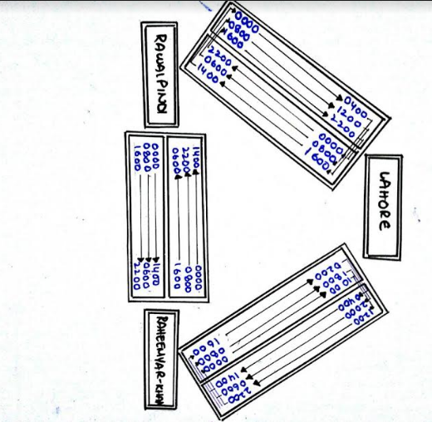
Flowcharts
Flowchart showing basic working of bus system:
Seating Function Flowchart

Single Seating Function

Multiple Seater Function Flowchart

En route Testing flowchart

Time Compatibility Function Flowchart

Special Feature:
The most important feature of our program is male female segregation with respect to seating. Most bus systems only provide interface and it is left up to the passenger to select seats accordingly else such problems are handled at the spot manually by the hostess. But our bus system provides check that no female is provided a seat next to a non-family male or no male is provided a seat next to a non-family female. Thus, this bus system not only provides bus environment according to the society; but also guarantees comfortable traveling for the passenger.
Testing and Validation:
After addition of every new feature; the program was tested by manual testing of code by multiple users. All errors and bugs encountered were fixed side by side. The major problems we encountered during the development of this system were logical errors majority of which were solved with the help of exceptional handling ,change in conditions for “for loops” and related statements and adding multiple “if else statements” for checking all possible conditions and getting rid of any erroneous inputs. One of the most important strategies employed, was syncing our project time with the system time by using <ctime> standard library. Other schemes we employed included handling all inputs with exceptional handling, allowing abbreviations and short forms as input in order to save time during process of booking entries. Another strategy employed by us of prime concern was dealing with sexual segregation in order to keep passengers satisfied. After applying all strategies, handling and fixing all problems and errors in the program through continuous and rigorous testing we have made sure that our program runs without any errors and facilitates as well as escalates the process of booking while storing data and making the process easier to be carried out.
Problem Specification:
During the process of creating a bus management and reservation system numerous problems were encountered including logical as well as systematic errors. Several hurdles were faced in the development of code while dealing with allotment, booking, data storage and record handling of multiple buses departing at multiple days and at multiple times a day from multiple terminals. Several complications were encountered for assuring availability of seats in the required buses. Undoubtedly, considerable complexity arose during the procedure of gender segregation in order to prevent the allotment of seats next to non-family female members. Another major setback encountered was infinite running of code on any incorrect input which needed to be solved as all humans tend to err. Incorrect condition checks of loops also resulted in infinite inputs being taken. Bookings by male members did not require input regarding family booking or single ticketing and directly booked for single ticketing. A number of errors were faced in array handling of buses, their departure timings and bus numbers. We solved most of the logical errors encountered by the help of exception handling. Some of the errors specifically related to seat adjustments and availability were solved by changing conditions of our loops and if else statements. Some of the errors related to syntax, semantics and compilation or run time errors were solved with the help of debugging. The standard library <ctime> required time for system time access which made program unsafe. By using #pragma warning (disable : 4996) the need of _s does not remain and thus the code ran successfully.
One of the errors encountered was that, during the process of acquiring system time the program stopped running for any possible time once all times had passed and did not move on to next possible time or even end the process.
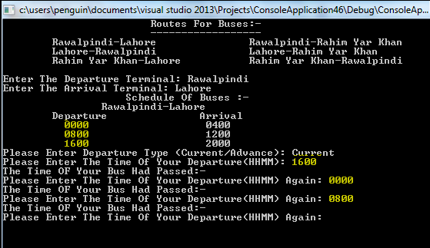
Improper implementation of the conditions of time in if else statements resulted in following error:
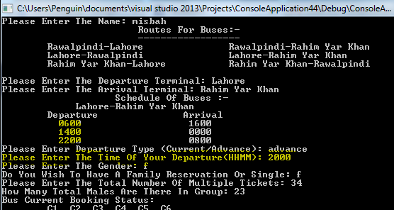

While handling multiple buses with 3D Arrays, buses retained data of previously entered input information for any other bus which was solved through debugging and fixing the code.
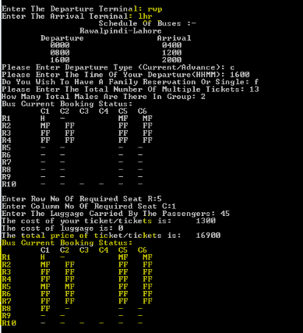
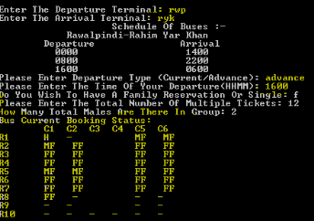

On entry of a single male the program itself filled two available seats with females.
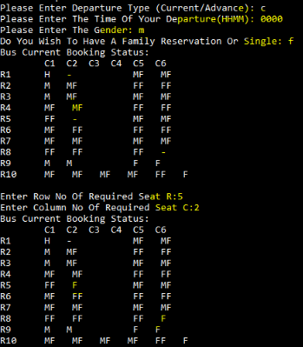
Errors related to seat allotment:
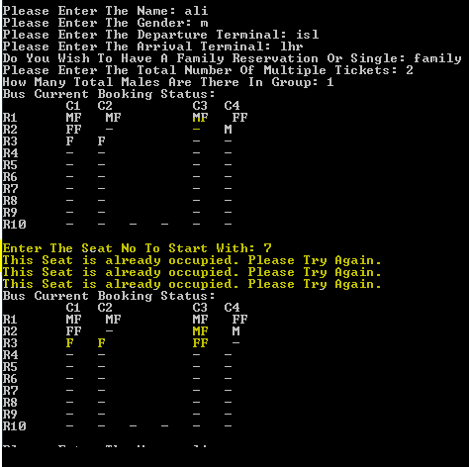

Errors related to gender segregation:
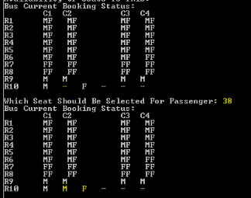
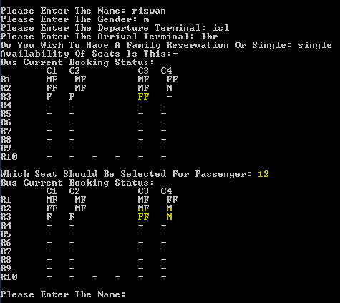

\
Logical Errors:
- Number of males entered as an input exceeded the number of family members entered as an input but the code continued to execute.
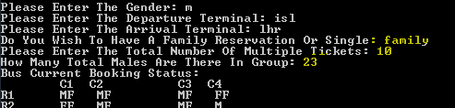

- Retake of input for 0 male members , although it was possible:
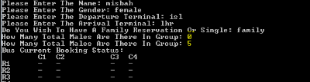

- Seat could not be offered due to unavailability of seats but incorrect message was displayed previously.
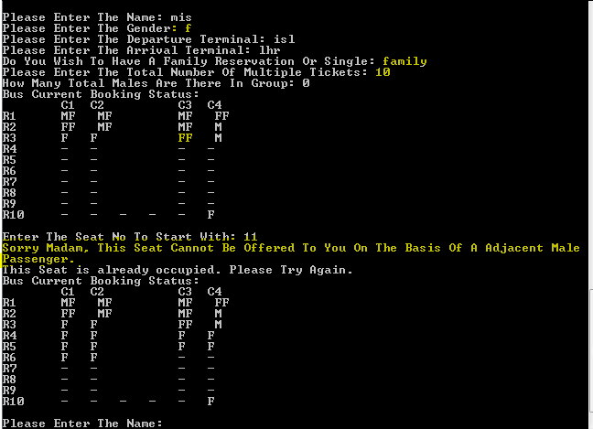

- Code did not take input for departure terminal.
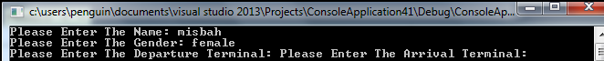
Errors resulting from incorrect loop conditions:
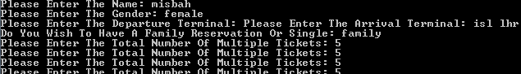
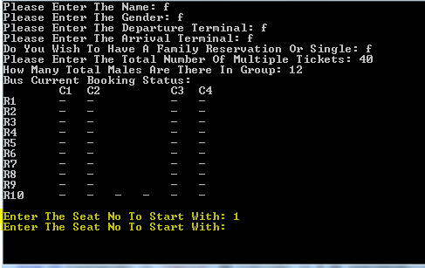

Future Development:
Even though we gave our best in generating a bus transportation and reservation system providing all necessary availabilities and options and the code was successfully implemented. But the project still lacked a few details and implementations due to certain limitations. Online booking feature could be added to the program in order to facilitate the customers to book rides from anywhere rather than having to visit the ticketing terminal. This addition can be made in future provided the appropriate circumstances, knowledge and skills. Apart from that, some additions could not be made as they required manual handling. For example, adding additional cost for smooth handling of fragile materials. As transportation includes food and other services and loading dock and passengers and sorting further issues of passengers regarding either discomfort in seats or requirement of a stop break in case of emergency. These elements can also be dealt manually rather than providing details through system. The system in the future can be made to store data related to employees of bus service and also to make the bus data program readable. An important addition would be the implementation of graphics in code to make the program more attractive. Another future development could include terminals from more cities rather than limited number of cities and buses for greater number of departure timings. Also it can be made possible for users to avail advance booking options for multiple days. Unfortunately, we had to place certain limitations due to availability of time.

Conclusion:
The Bus Transportation and Reservation system provides easy and efficient handling and storage of data of customers and bus details. Details include reservation, cancellation, seat allotments, seating on the basis of sexual segregation, advance and current bookings, luggage limitations and availability of buses for desired timings, printing of bus data, ticket printing, search inquiry and en route inquiry. This system has revolutionized the process of bookings of buses by computerizing the process and also saved time which was previously consumed by manual work. The program effectively stores all records through 3D arrays, assuring no data is lost and also makes data easily accessible. Now customers have a selection of multiple buses, on multiple days, multiple times during every day to book from.

Appendix:
- References:
Standard Libraries:
A standard library in computer programming is the library made available across implementations of a programming language.
- <ctime>: This header file contains definitions of functions to get and manipulate date and time information.
- <iostream>:Header that defines the standard input/output stream objects.
- <string>:This header introduces string types, character traits and a set of converting functions.
- <sstream>: Stream class to operate on strings.
- <fstream>: File streams. Input/output file stream class.
Directives:
The first lines that begin the program are directives. The first is a preprocessor directive,
and the second is a using directive.

- Preprocessor Directives:
Preprocessor directives are lines included in a program that being with the character #, which make them different from a typical source code text. They are invoked by the compiler to process some programs before compilation.
- #pragma warning(disable : 4996): This preprocessor directive is used when you don't want to pollute your source code with warnings.

- using namespace std::
The built in C++ library routines are kept in the standard namespace. That includes stuff like cout, cin, string, vector, map, etc. Because these tools are used so commonly, it's popular to add "using namespace std" at the top of your source code so that you won't have to type the std:: prefix constantly
Functions:
A function is a group of statements that together perform a task.
- stoi(): Converts string to integer.
- main():The main function is called at program startup after initialization of the non-local objects with static storage duration.
- Getter function: Used to take input.
- Setter Function : Used to set the values of data members.
Arrays:
Array is a data structure which stores a fixed-size sequential collection of elements/variables of the same type. C++ allows multidimensional arrays i.e. 2D and 3D arrays.
Pointers:
A pointer is a programming language object, whose value refers to (or "points to") another value stored elsewhere in the computer memory using its memory address. A pointer references a location in memory, and obtaining the value stored at that location is known as dereferencing the pointer.
Class:
A class in C++ is a user defined type or data structure declared with keyword class that has data and functions.
- Constructor: A constructor is a kind of member function that initializes an instance of its class.
- Destructor: A destructor is a special member function that is called when the lifetime of an object ends.
- Objects: "object" refers t
- No table of contents entries found.o a instance of a class where the object can be a combination of variables, functions, and data structures.
Inheritance:
Inheritance in Object Oriented Programming can be described as a process of creating new classes from existing classes. New classes inherit some of the properties and behavior of the existing classes.
- Base class: An existing class that is "parent" of a new class is called a base class.
- Derived Class: The derived class inherits all of the properties of the base class with additional features.
- Access Specifiers: The access restriction to the class members is specified by the labeled public, private, and protected sections within the class body which are called access specifiers.
Polymorphism:
Polymorphism means that a call to a member function will cause a different function to be executed depending on the type of object that invokes the function.
File Handling:
- File. The information / data stored under a specific name on a storage device, is called a file.
- Stream. It refers to a sequence of bytes.
- Text file. It is a file that stores information in ASCII characters. In text files, each line of text is terminated with a special character known as EOL (End of Line) character or delimiter character. When this EOL character is read or written, certain internal translations take place.
- Binary file. It is a file that contains information in the same format as it is held in memory. In binary files, no delimiters are used for a line and no translations occur here.

Classes for file stream operation:
- ofstream: Stream class to write on files.
- ifstream: Stream class to read from files.
- fstream: Stream class to both read and write from/to files.

File mode parameter | Meaning
ios::app | Append to end of file
ios::in | open file for reading only
ios::out  ios::left | open file for writing only  the output is padded to the field width appending fill characters at the end.

Exceptions:
A C++ exception is a response to an exceptional circumstance that arises while a program is running, such as an attempt to divide by zero. Exceptions provide a way to transfer control from one part of a program to another. C++ exception handling is built upon three keywords:
- throw: A program throws an exception when a problem shows up. This is done using a throw keyword.
- catch: A program catches an exception with an exception handler at the place in a program where you want to handle the problem. The catch keyword indicates the catching of an exception.
- try: A try block identifies a block of code for which particular exceptions will be activated. It's followed by one or more catch blocks.

Escape Sequences:
An escape sequence is a sequence of characters that does not represent itself when used inside a character or string literal, but is translated into another character or a sequence of characters that may be difficult or impossible to represent directly.
- \t : Horizontal tab.
- \n : line feed - new line
- \: Single quote.
- \":Double quote.
- \\: backslash/Comment
Data types:
Based on the data type of a variable, the operating system allocates memory and decides what can be stored in the reserved memory.
- Time_t: The time_t is a data type defined for storing system time values.
- Int: int is a fundamental type built into the compiler and used to define numeric variables holding whole numbers.
- char: it is a powerful data type used to handle and manipulate strings of characters.
- float: float is short for "floating point." It is a fundamental type built into the compiler and used to define numeric values with decimal points, which accommodate fractions.
- string: The term string generally means an ordered sequence of characters.
- bool: The Boolean data type is used to declare a variable whose value will be set as true (1) or false (0). To declare such a value, you use the bool keyword. The variable can then be initialized with the starting value. A Boolean constant is used to check the state of a variable, an expression, or a function, as true or false.
Statements:
A statement is a block of code that does something.
- if…else: The if else statement allows you to control if a program enters a section of code or not based on whether a given condition is true or false.
- system("pause"): It allows the program to wait until user hit enter so they can see their output on console.
- system("cls"): It is used to clear the screen in Visual C++.
- break: When the break statement is encountered inside a loop, the loop is immediately terminated and program control resumes at the next statement following the loop.Syntex:break;
- continue: The continue statement works somewhat like the break statement. Instead of forcing termination, however, continue forces the next iteration of the loop to take place, skipping any code in between.Syntax: continue;
- cin.get(): cin.get() forces the program to wait for the user to enter a key before it can close, and you can see the output of your program.
- getline: getline will read from the target IO Stream until a new-line character is found and store the result in the variable
- cout: Standard output stream..
- cin: Standard input stream.
- or(||):Executes a statement if either condition is satisfied.
- and(&&):Executes a statement if both conditions are satisfied.

Loops:
In computer programming, a loop is a sequence of instruction s that is continually repeated until a certain condition is reached.
- For-loop: A for-loop is a control flow statement for specifying iteration, which allows code to be executed repeatedly.
- While-loop: A while loop is a control flow statement that allows code to be executed repeatedly based on a given Boolean condition.
- Do While-loop: A do while loop is a control flow statement that executes a block of code at least once, and then repeatedly executes the block depending on a given Boolean condition at the end of the block.
Operators:
An operator is a symbol that tells the compiler to perform specific mathematical or logical manipulations.
- (::)Scope Resolution Operator
- (>>)Extraction Operator
- (<<)Insertion/Cascading Operator
- (%)Remainder/modulus operator
- (?:)Conditional/Ternary Operator

C++ is rich in built-in operators and provides the following types of operators:
- Arithmetic Operators
Operator | Description
+ | Adds two operands
- | Subtracts second operand from the first
* | Multiplies both operands
/ | Divides numerator by de-numerator
% | Modulus Operator and remainder of after an integer division
++ | Increment operator, increases integer value by one
-- | Decrement operator, decreases integer value by one

- Relational Operators
Operator | Description
== | Checks if the values of two operands are equal or not, if yes then condition becomes true.
!= | Checks if the values of two operands are equal or not, if values are not equal then condition becomes true.
> | Checks if the value of left operand is greater than the value of right operand, if yes then condition becomes true.
< | Checks if the value of left operand is less than the value of right operand, if yes then condition becomes true.
>= | Checks if the value of left operand is greater than or equal to the value of right operand, if yes then condition becomes true.
<= | Checks if the value of left operand is less than or equal to the value of right operand, if yes then condition becomes true.

- Logical Operators
Operator | Description
&& | Called Logical AND operator. If both the operands are non-zero, then condition becomes true.
|| | Called Logical OR Operator. If any of the two operands is non-zero, then condition becomes true.
! | Called Logical NOT Operator. Use to reverses the logical state of its operand. If a condition is true, then Logical NOT operator will make false.

- Assignment Operators
Operator | Description
= | Simple assignment operator, Assigns values from right side operands to left side operand
+= | Add and assignment operator, It adds right operand to the left operand and assign the result to left operand
-= | Subtract and assignment operator, It subtracts right operand from the left operand and assign the result to left operand
*= | Multiply and assignment operator, It multiplies right operand with the left operand and assign the result to left operand
/= | Divide and assignment operator, It divides left operand with the right operand and assign the result to left operand
%= | Modulus and assignment operator, It takes modulus using two operands and assign the result to left operand

- Misc Operators
Operator | Description
Condition ? X : Y | Conditional operator. If Condition is true ? then it returns value X : otherwise value Y
, | Comma operator causes a sequence of operations to be performed. The value of the entire comma expression is the value of the last expression of the comma-separated list.
. (dot) and -> (arrow) | Member operators are used to reference individual members of classes, structures, and unions.
& | Pointer operator & returns the address of an variable. For example &a; will give actual address of the variable.
* | Pointer operator * is pointer to a variable. For example *var; will pointer to a variable var.
- Test Output:

Following are outputs of our program:

Ticket(Destination File):
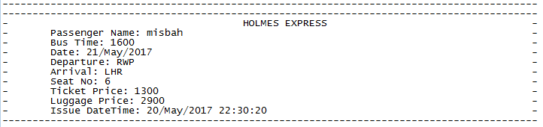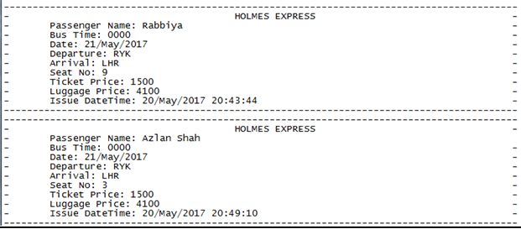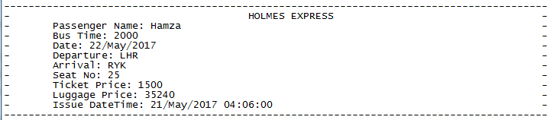
Bus Data Destination File:
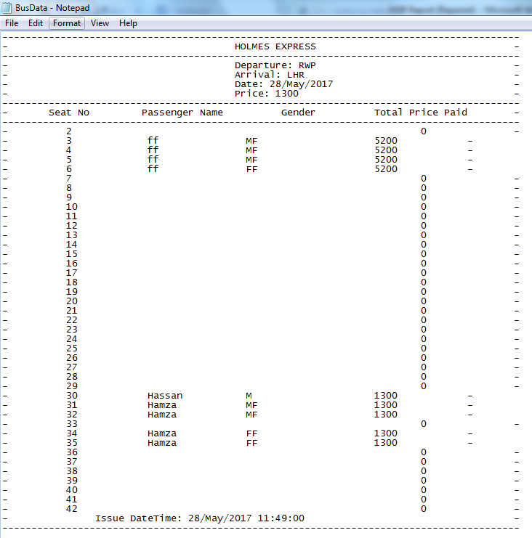
Search Data Destination File:
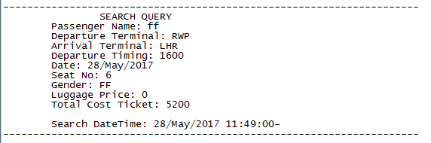

Console Output:

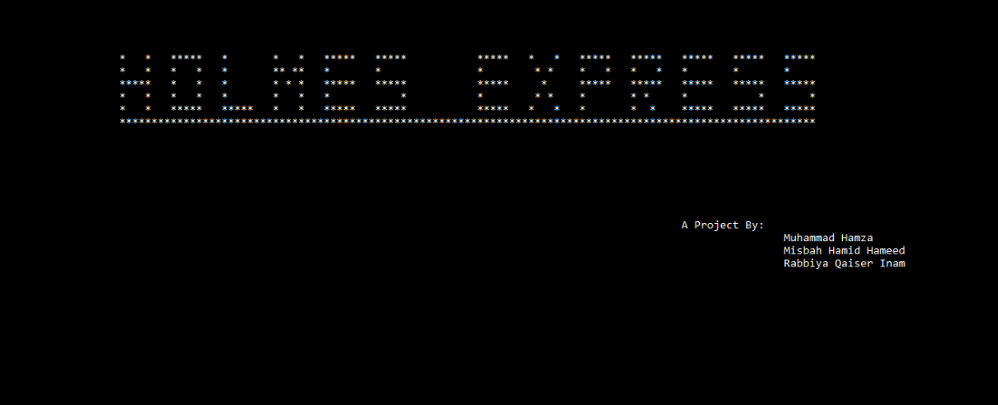

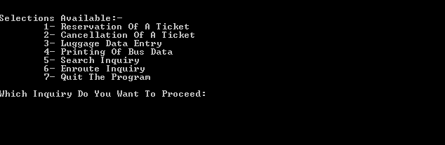
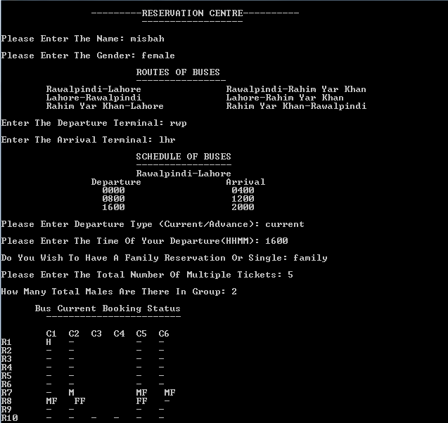
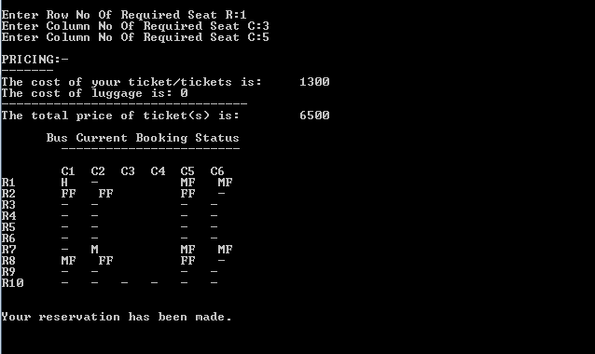

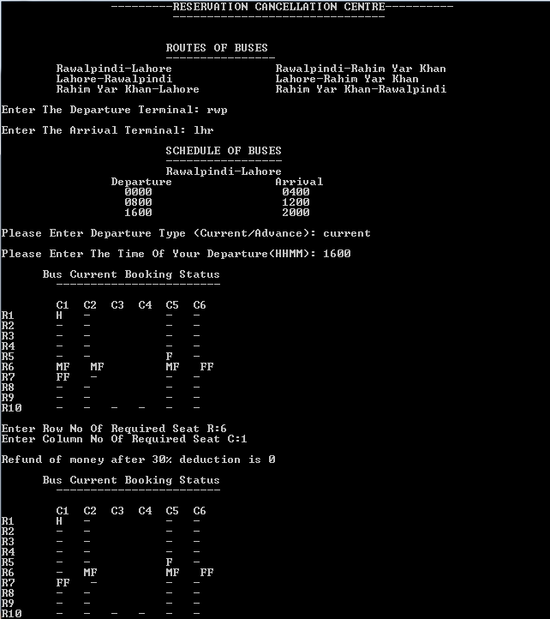

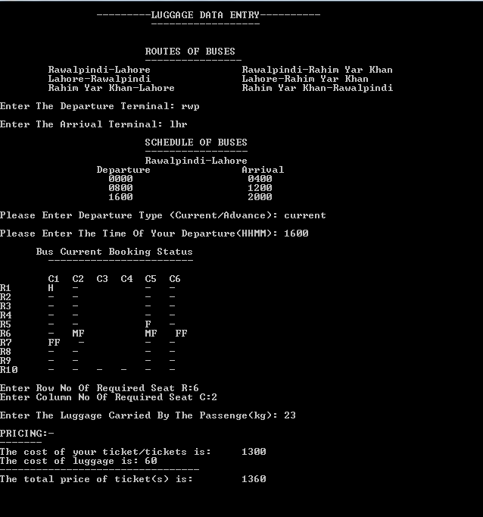
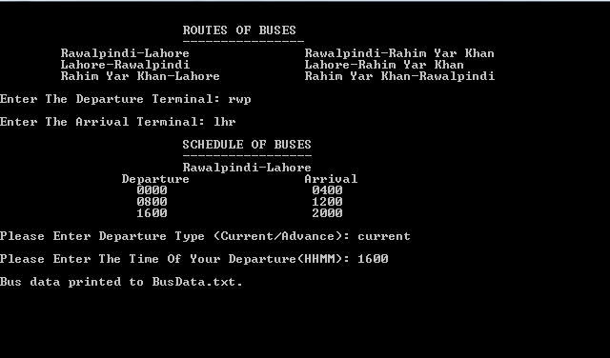
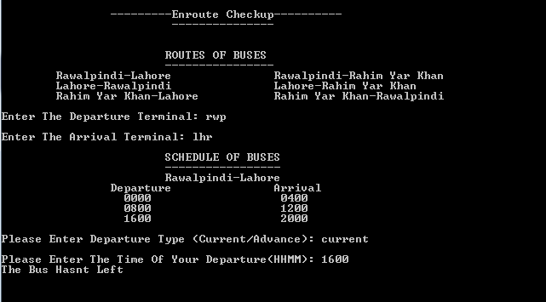

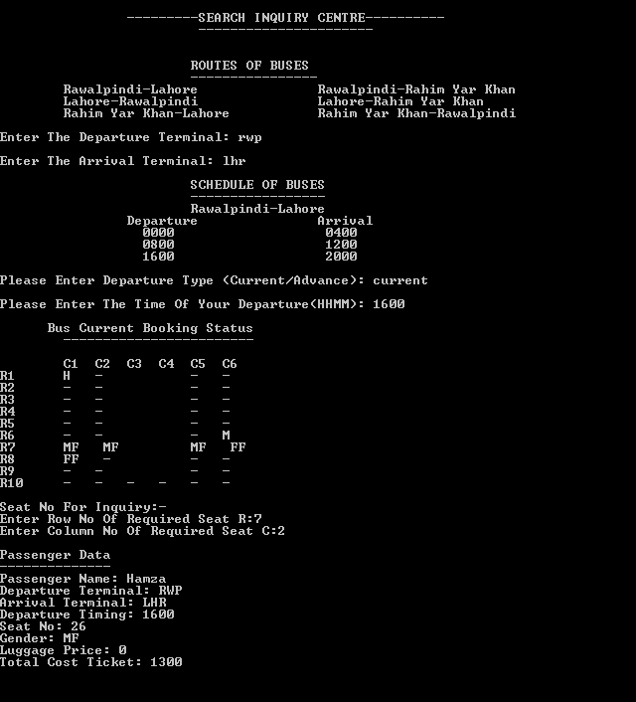

- Concluding Comments:
During the compilation of this report based on our project of Bus Transportation and Reservation System we wrote down an abstract and conclusion concerning the crux of our project. We highlighted the problems we encountered during the process of making the project along with the solutions. We provided information about the basics of our program and its elements. Additionally, we provided a detailed design of our program. We described the methods through which we tested and validated our program and also put forward our main strategies during development of code. We explained the short comings of our program resulting from certain limitations and the possible future developments. Furthermore a detailed user manual and appendix has been provided with short description of all relevant terms, functions, data structures, libraries etch.

